Lab 3
Mark: 20

Capture/Analyse Local Communication Process
Things that you will need to know or learn:
• Identify and understand the different addressing layers necessary for successful communication.
• Understand the local communication process.
• The general purpose and format of an ARP message.
• Understand the information provided in the Wireshark Details Pane to extract addressing information and map protocols to their OSI or TCP/IP network model layers.
• Connecting to a web server
• Determining your network adapter’s MAC address.

What you need to submit and when:
Complete the in-lab part of the lab and demo it in class to your lab instructor.

Required Equipment/Software:
A partner
Two laptops
• Network cables and Linksys router
• Wireshark installed
• Lab documents downloaded to your laptop (this document)
• Webserver.exe file downloaded to your laptop (download folder)

Task 0: Preparation
1- Find a partner to work with.
2- Disable the Wireless Network Interface, all VMware cards, and anti-virus, your only connection to the network must be via the Ethernet (wired) interface.
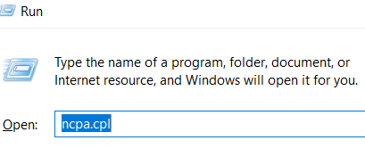
Go to Run by Clicking on the Windows icon + R.
In the Open box type ncpa.cpl and press enter

Right-click on the NIC cards in the Network connection screen and choose Disable.
make sure you disable all cards except the Ethernet card.
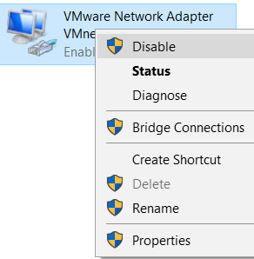

3- Do not start until you have completed ALL steps in this task.
4-Connect both laptops to the Linksys router via Ethernet port (1,2,3,4)
5- Now find your Wireless IP address and take a screenshot.
Example:
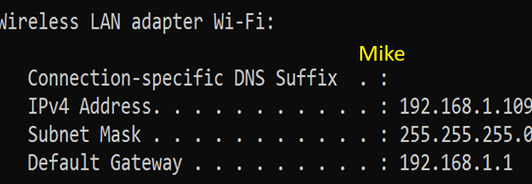

Your Screenshot here

What command did you use to get your IP address? (1 mark)
ipconfig /all

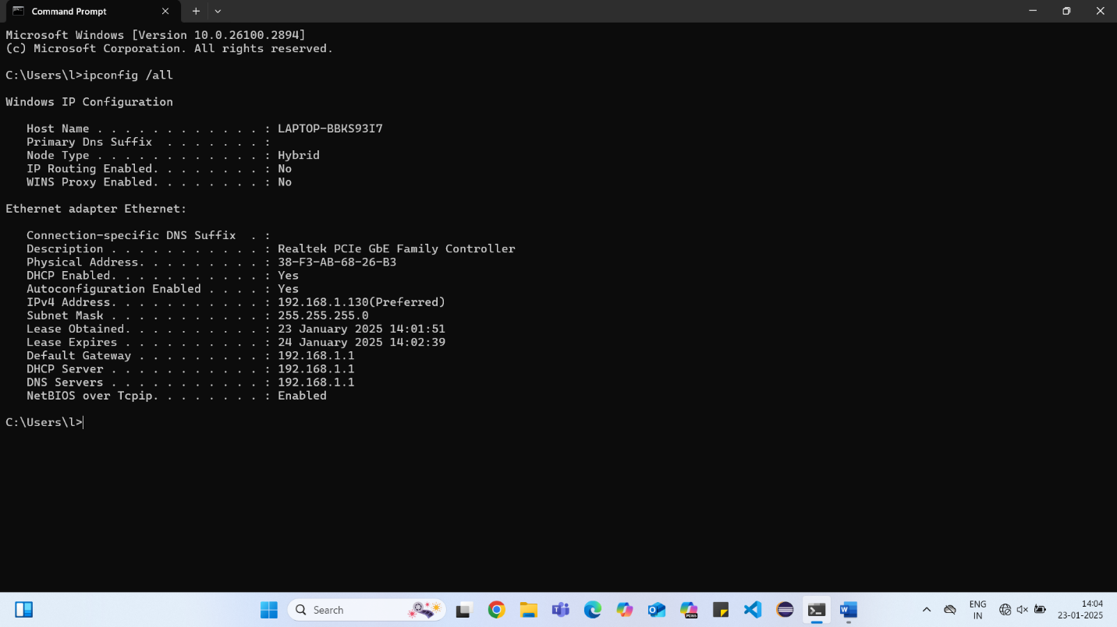
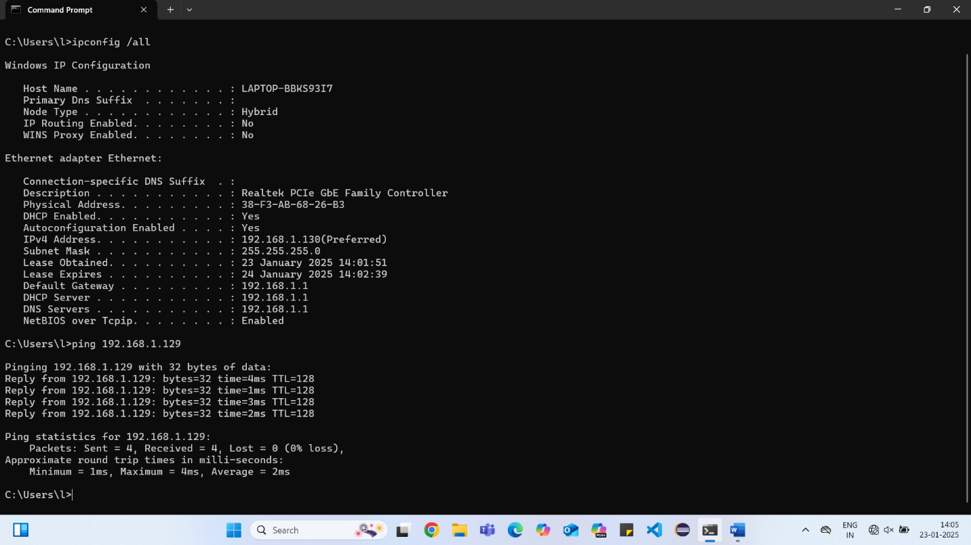

Task 1: Build a Network with Linksys Router
In this task, you will build and test a network that consists of three physical devices: your laptop, your partner’s laptop (end device), and a Linksys router (intermediary).
Do not start Task 1 until you have completed all Task 0 steps.

1- Obtain a Linksys router (one per team), power adapter, and the required cables.
2- Power on your Linksys router and wait until the router’s green power indicator LED is on steadily before proceeding to the next step. Note that the power indicator light flashes slowly during boot-up router reset and firmware upgrades.
3- Reset the router back to factory defaults.
4- Ensure your Laptop’s Ethernet network adapter is configured to obtain its IPv4 address automatically via Dynamic Host Configuration Protocol (DHCP-Linksys router).

To check your Ethernet card: Go to Run, and type ncpa.cpl press enter. Right-click on your Ethernet, choose properties, and click on Internet Protocol Version 4 (TCP/IP). Make sure the Ethernet card says to obtain an IP address automatically.
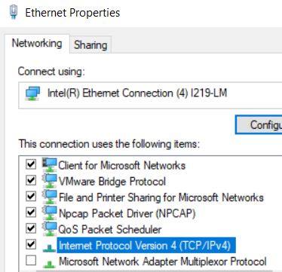

Repeat for your partner’s laptop.

5- Using the correct cable connect your laptop’s Ethernet network adapter
to any of your Linksys router’s switch’s Ethernet ports (1,2,3,4). Your laptop
will attempt to obtain an IPv4 address from your Linksys DHCP server
(Router). Please be patient as this process may take up to 60 seconds.

What type of cable did you use to connect your laptop to the Linksys router? (1 mark)

Cross-Over Cable

6- Ensure that the green light corresponding to the Linksys’s Ethernet port you connected into is flashing. This is an indication that there is network activity on the port.

7- At the Windows command prompt (CMD), type ipconfig /all. What is your IP, DG, and MAC (physical) address? What is your partner’s IP, DG, and MAC address? (ask her/him)
(6 marks)
Your IPv4 address: 192.168.1.130
Subnet Mask: 255.255.255.0
Default Gateway: 192.168.1.1
Your MAC address: 38-F3-AB-68-26-B3

Your partner’s IPv4 address: 192.168.1.129
Subnet Mask: 255.255.255.0
Default Gateway: 192.168.1.1
MAC address: 7C-C2-C6-52-DE-AA
Compare your Default gateway address value with your partner. Are they the same? Why? (explain)
Because the routers are the same

9- You will verify basic connectivity (layer 3) to your Ethernet network. Ping your DG:

Example: ping 192.168.1.25
A successful ping will look similar to this: Pinging 192.168.1.25 with 32 bytes of data:
Reply from 192.168.1.25: bytes=32 time<1ms TTL=255
Reply from 192.168.1.25: bytes=32 time<1ms TTL=255
Reply from 192.168.1.25: bytes=32 time<1ms TTL=255
Reply from 192.168.1.25: bytes=32 time<1ms TTL=255
Ping statistics for 192.168.1.25:
Packets: Sent = 4, Received = 4, Lost = 0 (0% loss),
Approximate round trip times in milli-seconds:
Minimum = 3ms, Maximum = 9ms, Average = 5ms

Task 2: Install and Test the Web Server
In this task, you will assign roles to each laptop. You will need one laptop to play the role of client and the other the role of server on which the web server software (file) will run.
Either laptop should be able to play the role of server, and the other laptop will play the role of the client. No special software is required on this laptop.

- On the laptop you have assigned to be the web server, install the Webserver software by running the Webserver.exe file (the file you downloaded in task 0 in the download folder). You will be prompted for the extraction location. Extract to a new folder location or an existing empty folder location.

2- Disable any firewalls on both laptops.

3- Navigate to the location where you extracted the files. Run the wwebser.exe as administrator. The following window will appear. Uncheck the box “Start automatically when System starts up (No NT-Server!)”. Modify the Port value from 1080 to 8088.
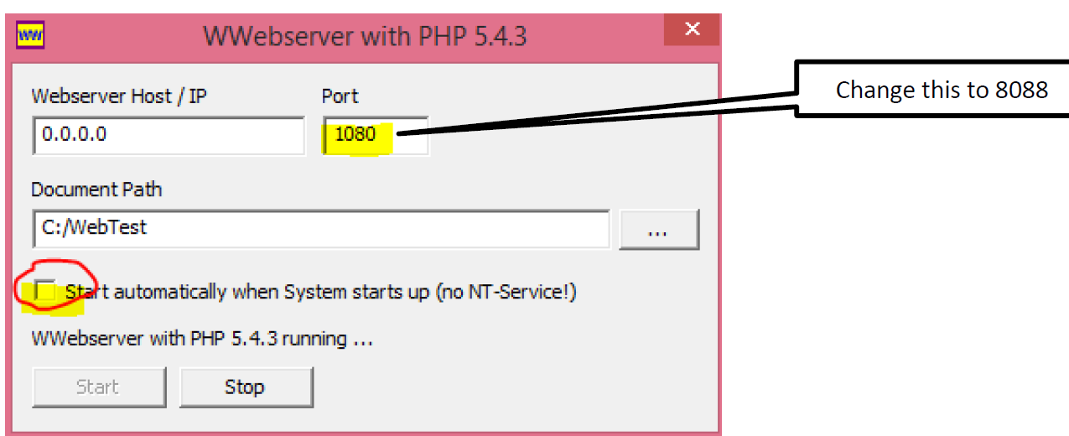
4-Make sure the Document Path, is not in one drive.

Click Start to start the web server.
The 0.0.0.0 value in the Webserver Host/IP field indicates that the web server listens for web client requests on all IP addresses assigned to the laptop running the web server software.
The port 8088 value indicates that the web server is listening for client requests on port 8088. Note that the standard port is port 80 for non-secure communication and port 443 for secure communications.

Note: if you have a problem with server software running on your PC, stop it first and then go to the taskbar in your PC, right-click on the WWW, and then exit.


5- Server laptop: Connect to the web server from the web browser (Chrome, Firefox) running on the web server laptop.

Type in the following in the web browser’s address bar:

http://a.b.c.d Replace a.b.c.d with the web server’s IP address.
A web page displays the client and server IP address values should appear. This is an indication that your web server is working. (White page with client and server IP address)
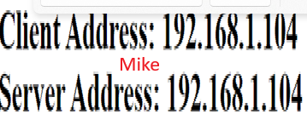

6- Client laptop, open the browser (Chrome, Firefox) and Type the web server IP address in the browser’s address bar: (http:// a.b.c.d ). A web page displays the client and server IP address values should appear. This is an indication that your web server is working.
DO NOT proceed until the web page successfully displays on both client and server laptops. (1 mark)
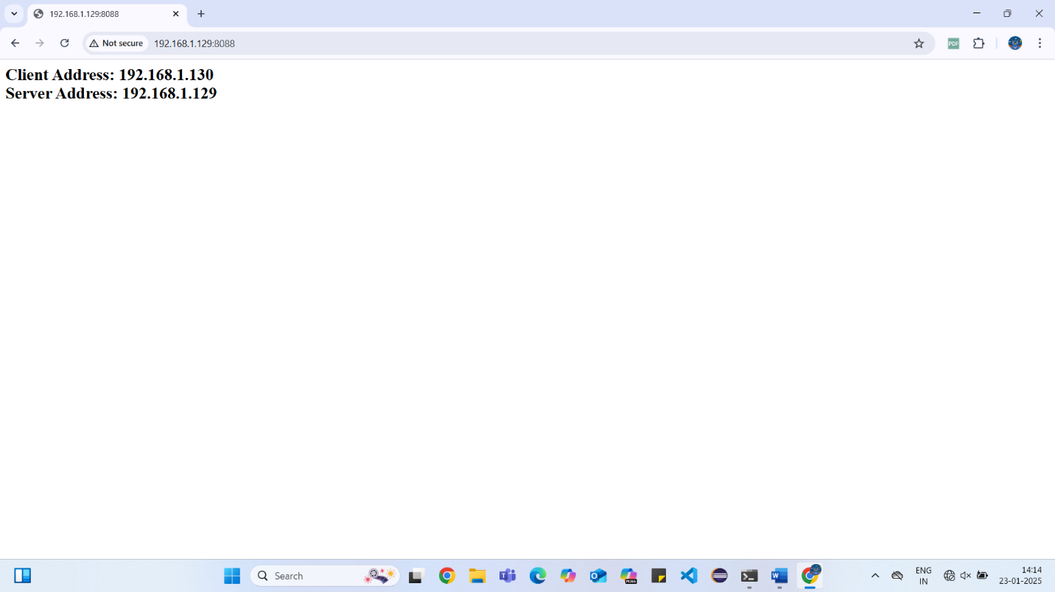

Your screenshot of activity 6 here.

Note: If step 5 succeeded but 6 failed, then make sure the firewall on the web server laptop has been disabled. This is not the preferred solution but will do until such time that you have learned how to create firewall rules.

Task 3: Accessing Local Resources (
In this task, you will capture the network traffic between a web client and a web server each running on the same network segment. (Local network)
Do not proceed until all previous tasks have succeeded!

1-How to delete the ARP cache: ARP: Address Resolution Protocol) on both laptops, run CMD as Administrator. (command prompt).
What is ARP? It is a protocol that resolves an IP address to a MAC (physical address) in a local network.
From the Command Prompt windows, enter the following command: arp -d *
2-check the arp cache: arp -a and make sure there are no arp entries found.
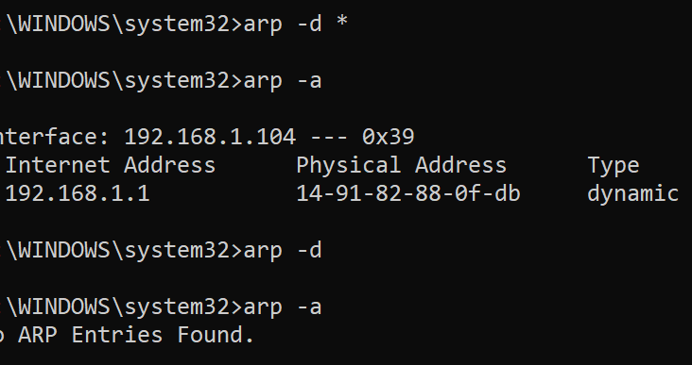

Note: if you see some entries in your PC (CMD) after you run the arp -d * command, that is considered normal. The reason is that your laptop constantly communicating with the router (Linksys), therefore you are getting some entries.

3- On both laptops, start a Wireshark capture first. Make sure you capture traffic on the correct interface! (Ethernet adapter).

4- On the client's laptop, open a web browser. Enter the following URL in the browser’s address bar: http://a.b.c.d replace a.b.c.d with the web server’s IP address.
Do not proceed to the next step until the web page successfully displays in the web browser.

5- Stop the Wireshark capture on both client and server. Save the captures. (1 mark)

Insert a screenshot of your WS here
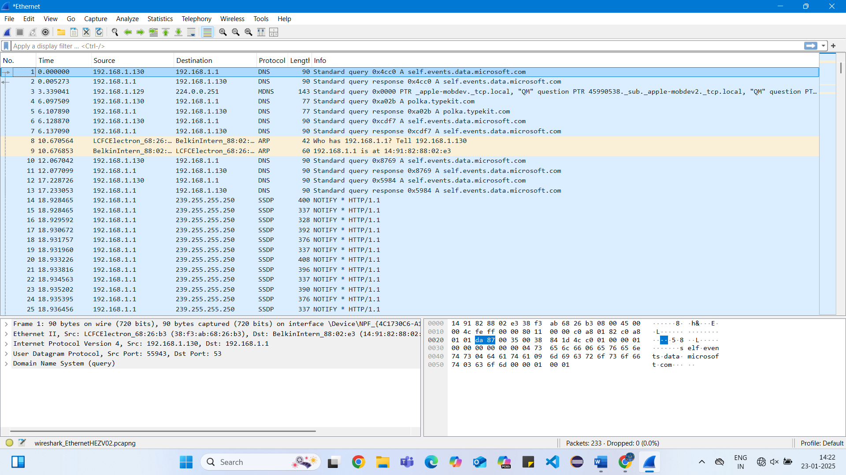

Task 4: Validate Wireshark Capture
In this task, you will ensure that the task 3 capture contains all required frames. (layer 2)

1- Filter (WS) by arp and look for a captured frame having the following in the info column:

Who has a.b.c.d? Tell w.x.y.z (who has server IP to tell client IP)
a.b.c.d is the web server’s IP address.
w.x.y.z is the client’s IP address.

2- Filter by HTTP and look for two captured frames having the following characteristics:

First Frame - Client Request
GET / HTTP/1.1 in the info column.
where w.x.y.z in the source column (client IP)
a.b.c.d in the destination column (server IP)

Second Frame - Server Response
HTTP/1.1 304 Not modified OR
HTTP/1.1 200 OK in the info column
where w.x.y.z in the destination column (client IP)
a.b.c.d in the source column (server IP)

3- You must repeat task 3 if either of the 1 or 2 results do not meet the requirements.
Task 5: Local Communication Analysis (10 mark)
1- In Wireshark, select the frame that encapsulates the client request (identified in 2) and examine the message’s PDU details in the Details Pane to answer the following questions.

a. What is the layer 7 protocol? HTTP

b. What is the Layer 4 protocol? TCP

c. What is the Layer 3 protocol? NETWORK LAYER

d. What is the Layer 2 protocol? Ethernet ||

e. What is the frame’s destination MAC address?

7c:c2:c6:52:de:aa

i. This destination’s MAC address belongs to which device? The server laptop

f. What is the destination IP address? 192.168.1.129

i. This IP address belongs to which device? The server laptop

g. What is the destination port? 8088

i. This destination port belongs to which application? Web server

